STREET FIGHTER COURSE GEAR LIST
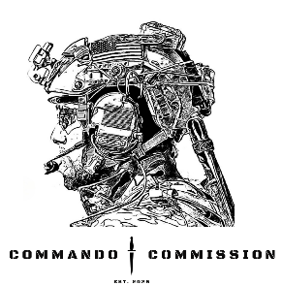

Carbine/Rifle 5.56 * Carbine sling * Weapons Cleaning Kit CLP / Gun Oil *
4 Magazines 5.56 *
Handgun 100 Rounds
2 Magazines 9mm
Hiking Boots / Durable Shoes

5.56 Ammunition 500 Rounds * Handgun Holster
Hearing Protection (Electronic Preferred) * Eye Protection (Clear or Dark Lense) * Shooting Gloves*
Gun Belt / Duty Belt *

Rifle Magazine Pouch (On Belt) * Pistol Magazine Pouch (On Belt)
IFAK (On Belt or Kit) *
Plate Carrier with Plates or Chest Rig

3 Rifle Magazine Pouches Minimum (On Kit) * Ops Core Helmet (LEO Required)
Combat Top/ Shirt (Long Sleeve or Short) * Combat Pants / Pants
Knife / Multitool

Extra Batteries (AA, AAA, CR123) Black Sharpie
Range Box / Bag

Fix it Sticks or Small Tool Kit Lunch / Food / Snacks *
Water Bottle / Gallon Water Jug *

